ASSIGNMENT 05

NAME -- ROHAN KUMAR

SEC -- C

ROLL NO -- 52

UNI.ROLL NO –191500669

DATE – 4 August 2020

Course: B.Tech. (CSE)

Year: 2nd Semester : 3rd

SUBMITTED TO – Miss Nidhi

#### 1.uniq

#### Used along with sort command to display repeating lines only once if repeated lines are adjacent.

Syntax-

uniq -c filename -It tells no of times a line was repeated by displaying a number as a prefix with the line.

uniq -d filename -It only prints the repeated lines and not the lines which aren’t repeated

uniq -u filename -It allows you to print only unique lines.

Uniq -I filename – It allows to print non-repeated lines only.

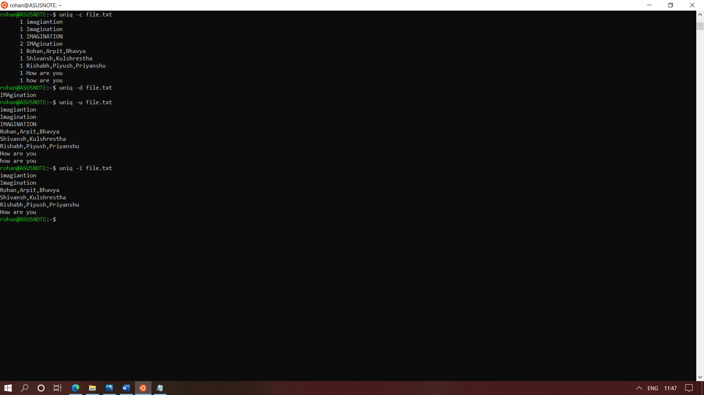

#### 2. chmod

#### Used for changing file permissions

#### **Syntax**

chmod [reference][operator][mode] file

* 0 No permission
* 1 Execute permission
* 2 Write permission
* 3 Write and execute permissions
* 4 Read permission
* 5 Read and execute permissions
* 6 Read and write permissions
* 7 Read, write and execute permissions

| **Operator** | **Description** |
| --- | --- |
| + | Adds the specified modes to the specified classes |
| - | Removes the specified modes from the specified classes |
| = | The modes specified are to be made the exact modes for the specified classes |

| **Reference** | **Class** | **Description** |
| --- | --- | --- |
| u | owner | file's owner |
| g | group | users who are members of the file's group |
| o | others | users who are neither the file's owner nor members of the file's group |
| a | all | All three of the above, same as ugo |

#### 

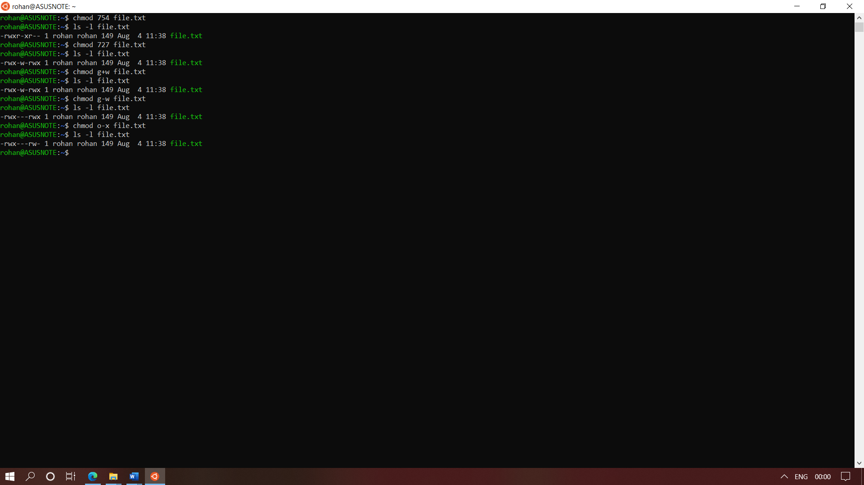

#### 3.du

#### du command, short for disk usage, is used to estimate file space usage.

#### The du command can be used to track the files and directories which are consuming excessive amount of space on hard disk drive.

-0, –null : end each output line with NULL

-a, –all : write count of all files, not just directories

–apparent-size : print apparent sizes, rather than disk usage.

-B, –block-size=SIZE : scale sizes to SIZE before printing on console

-c, –total : produce grand total

-d, –max-depth=N : print total for directory only if it is N or fewer levels below command line argument

-h, –human-readable : print sizes in human readable format

-S, -separate-dirs : for directories, don’t include size of subdirectories

-s, –summarize : display only total for each directory

–time : show time of last modification of any file or directory.

–exclude=PATTERN : exclude files that match PATTERN

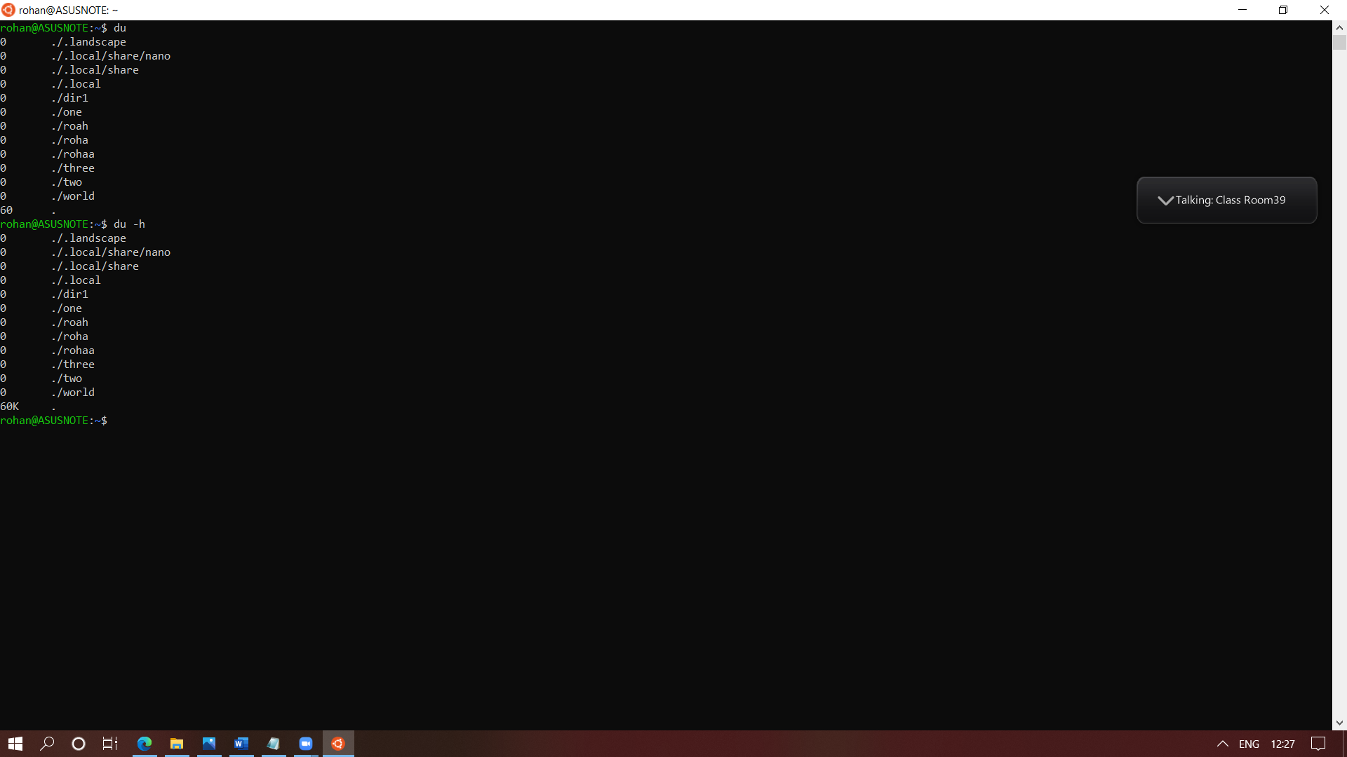

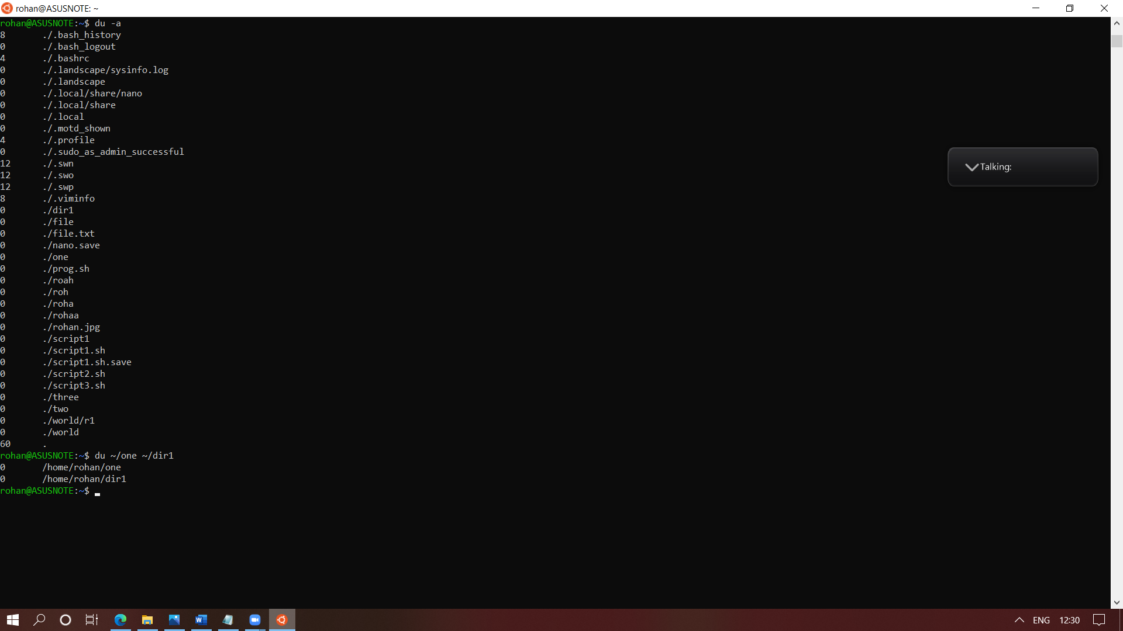

### 4. diff

### This command is used to display the differences in the files by comparing the files line by line.

1. -c context mode
2. -u unified mode
3. -i(case insensitive)

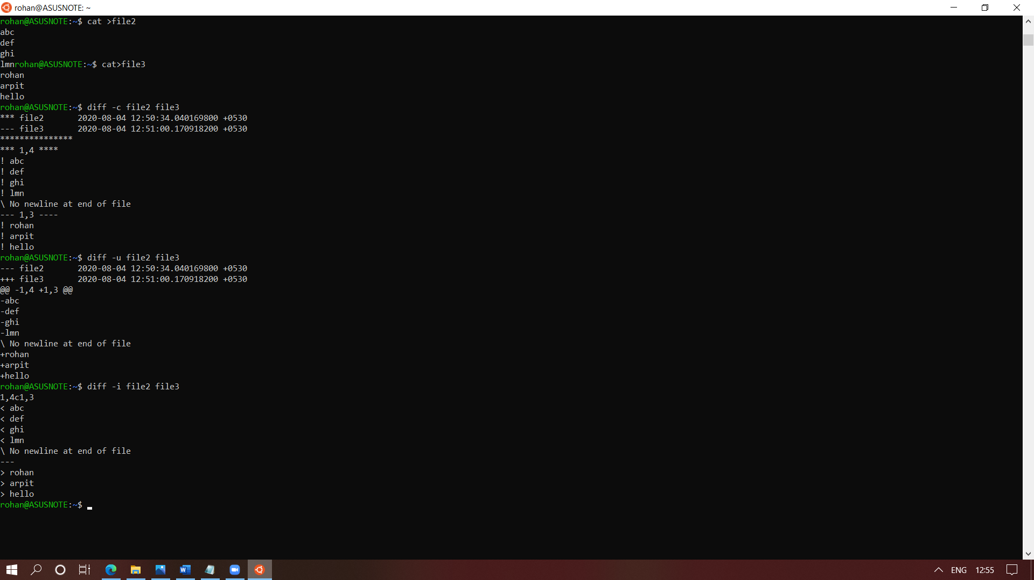

### 5. history

### history command is used to view the previously executed command.

Syntax :-

* history –show the history
* history -d 3 – to delete that number in history
* history – clear the history

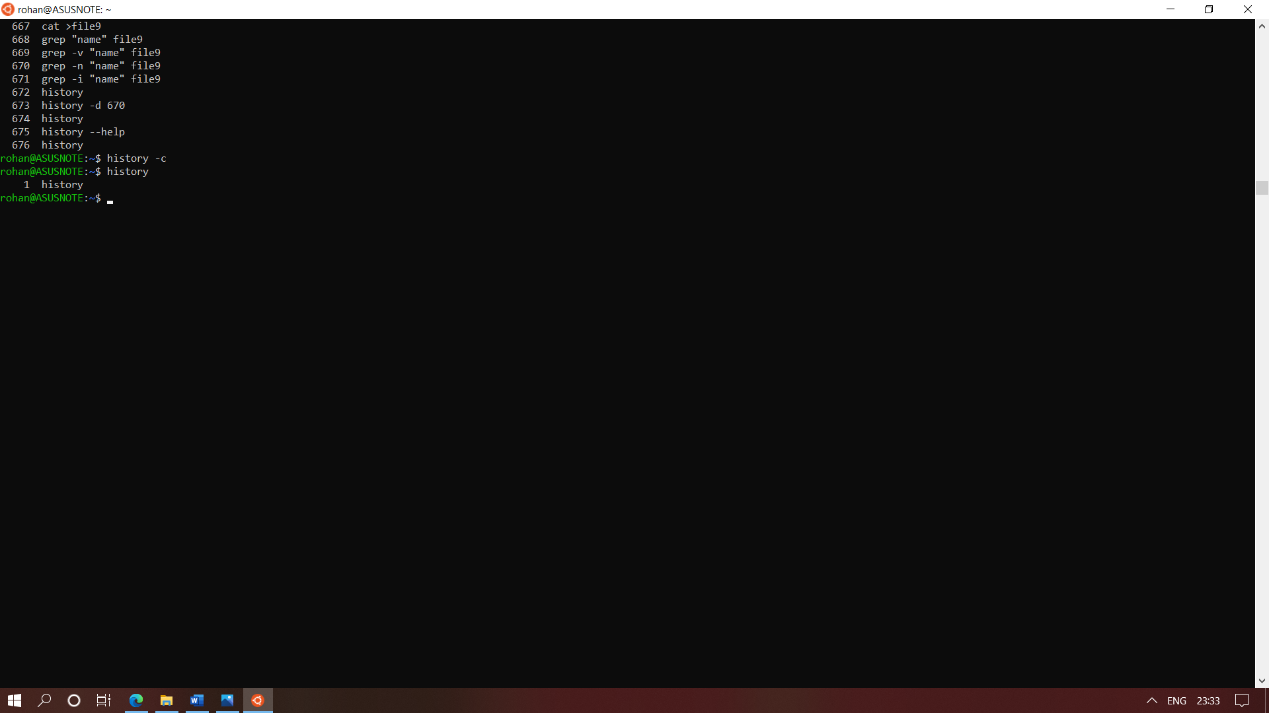

### 6. Last –it is used to view the last login of the user

### 

#### 7.sort – it is used to sort the contents of a file

#### Syntax –

* sort filename –sort the contents of a file(for numbers it only sort the first digit of a number
* sort - n filename –sort according to numbers
* sort -nr filename ---sort numbers in reverse order
* sort -r filename – sort alphabetically
* sort -o file1 file2 – sort and save the contents of file2 in file1
* sort -o file1 -r file2 –sort and save the contents of file2 in file 1 in reverse order

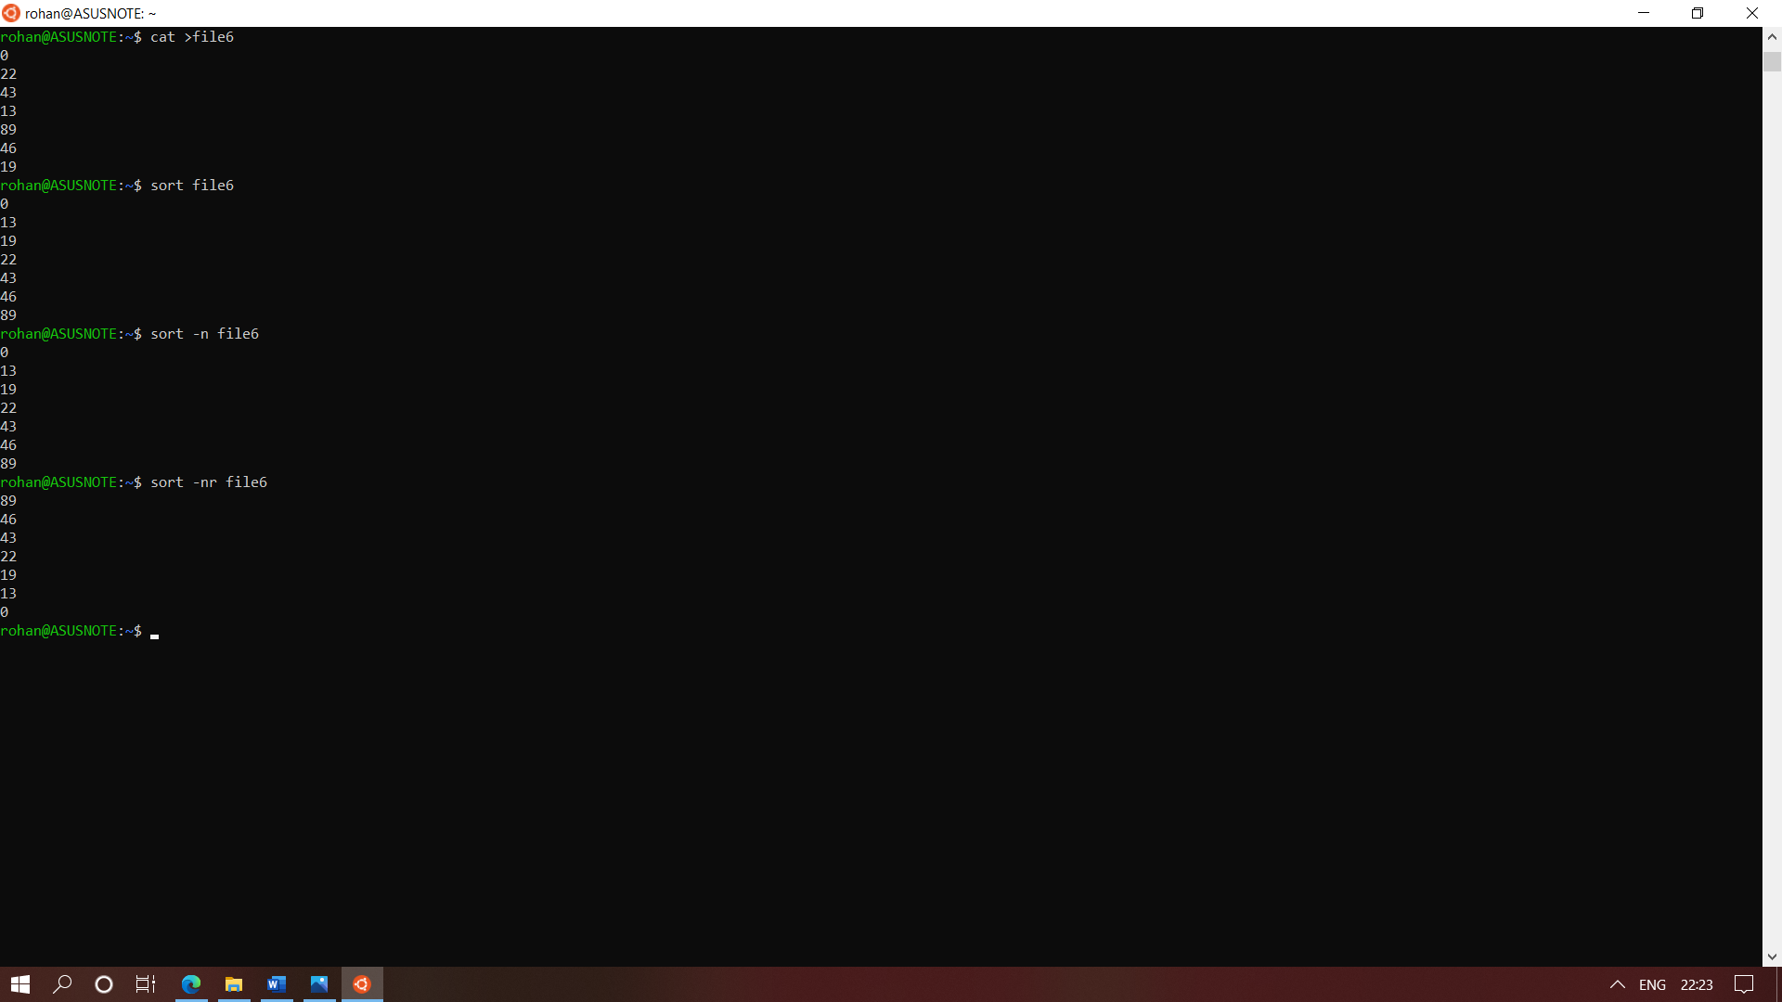

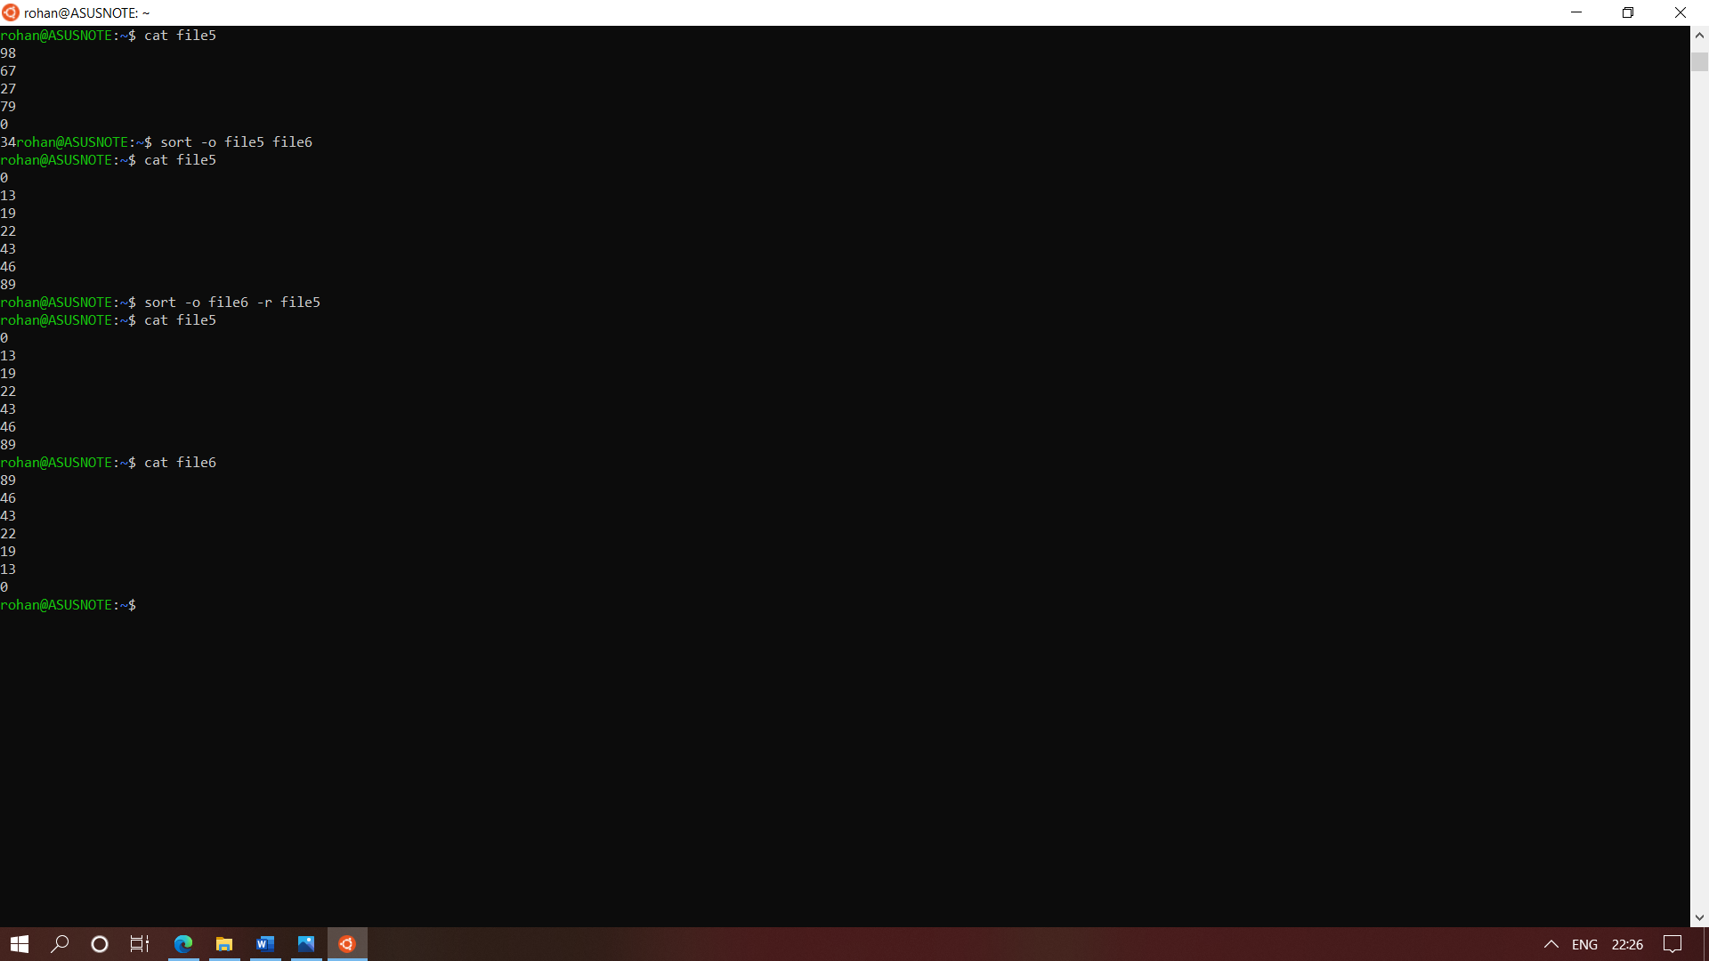

### 8. SED is a powerful text stream editor. Can do insertion, deletion, search and replace(substitution).

* sed ‘0/n/n2/’ file7 – to change the first occurrence of n
* sed ‘s/n/n2/g’ file7 – to change all occurrence of n
* sed ‘s/n/n2/2’ file7 – to change upto 2 line
* sed ‘s/n/n2/2g’ file7 – to change from 2nd to the last line

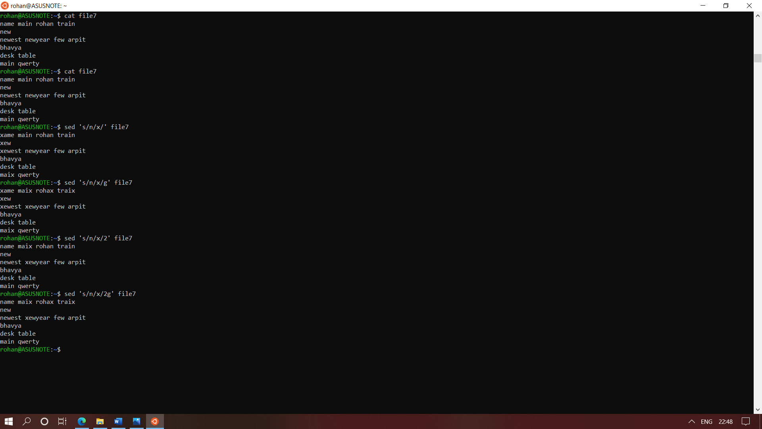

### 9.sed – to delete

* sed ‘4d’ file7 – delete fourth line
* sed ‘$d’ file7 –to delete last line
* sed ‘3,4d’ file7 -- to delete 3 – 4th line
* sed ‘3,$d’ file7 –to delete 3rd to last line
* sed ‘/m/d’ file7 – to delete ‘m’ from file
* sed ‘/m/d ; /o/d’ file7 –to delete ‘m’ and ‘o’ from file

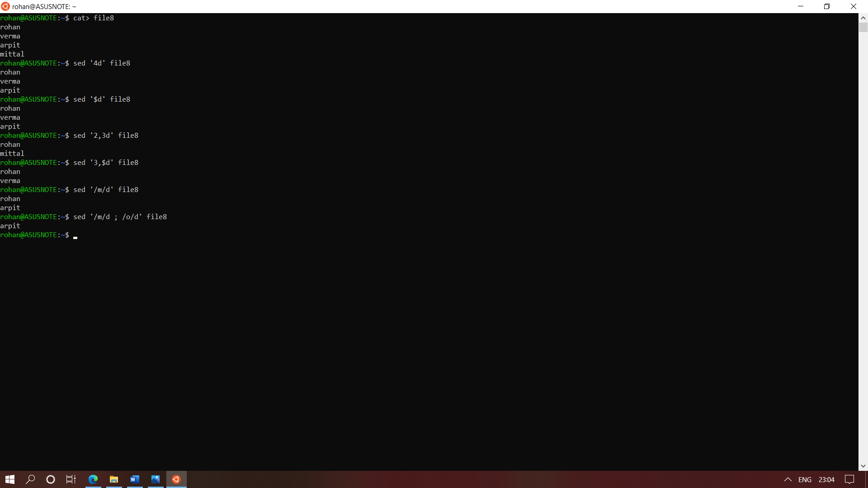

### 10.grep

### The grep filter searches a file for a particular pattern of characters, and displays all lines that contain that pattern.

### **Syntax:**

grep [options] pattern [files]

* grep “name” file9 –line which match “name”
* grep -v “name” file9 –lines which do not contain “name”
* grep -c “name” file9 –no of lines match
* grep -n “name”file9 – no of line +line
* grep -I “name” file9 – to consider uppercase and lowercase

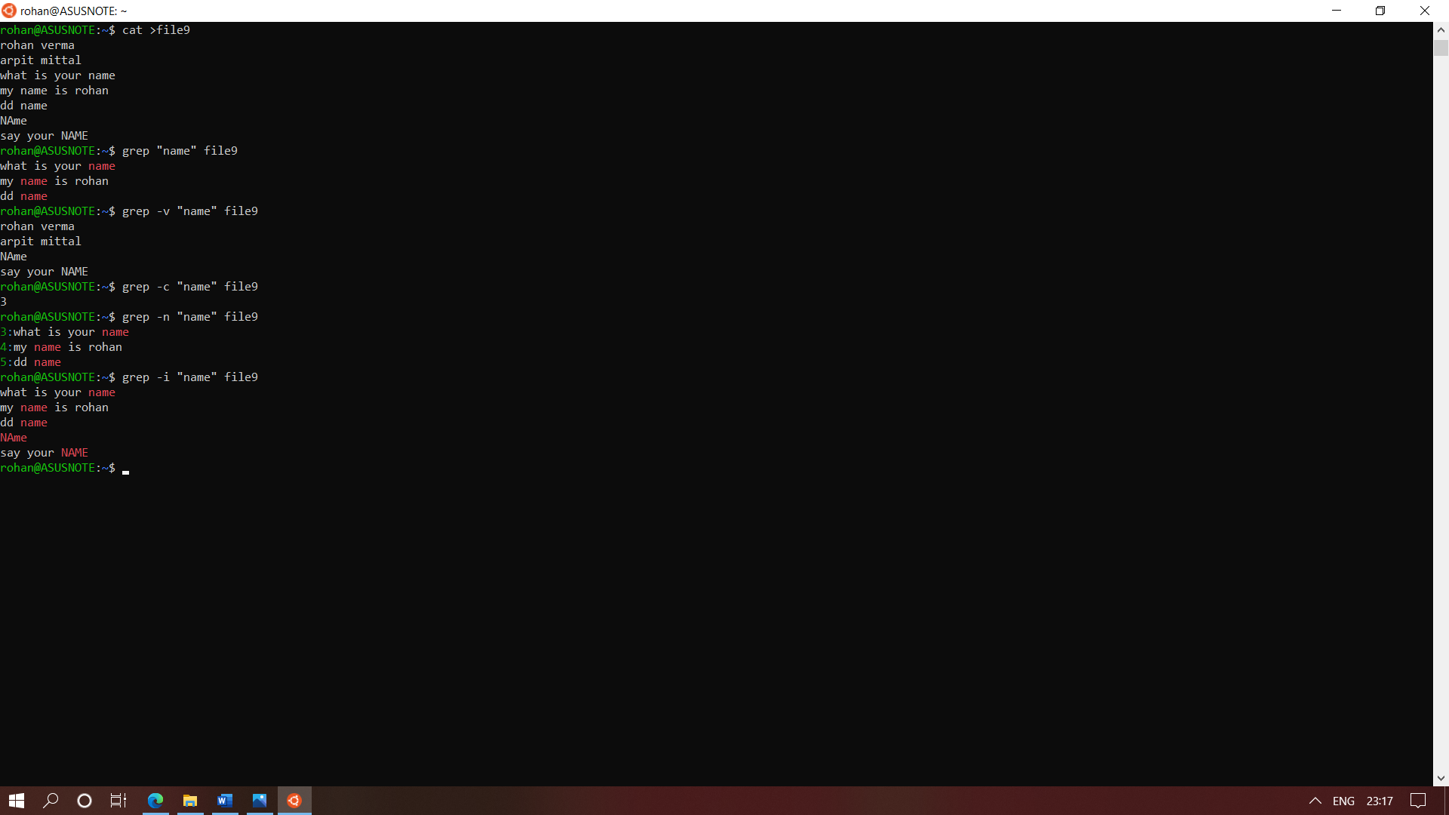

#### 11.cut command—

* cut -c 1 filename ----- to take out the first character from the file
* cut -c 3 filename ------to take out hr 3rd character form the file
* cut -c 3- filename ------to take out the characters no 3 to last from the file
* cut -c 3-5 filename ---- to take out the characters no 3 to the fifth characters from the file
* cut -d “,”-f 1 filename – to take out charcaters from the file from the “,” delimiter

